SHEET 1
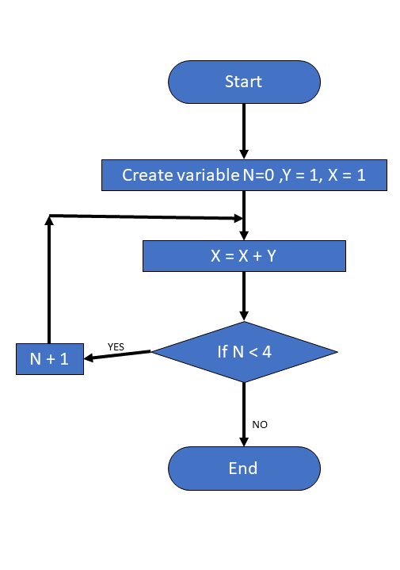
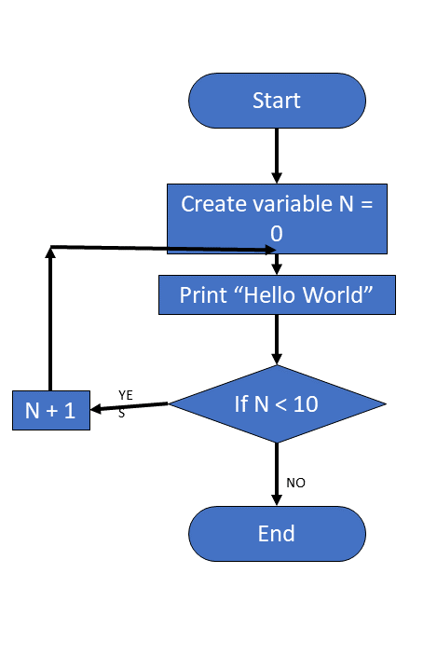

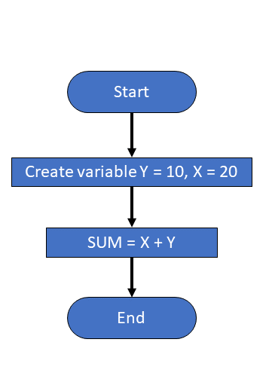

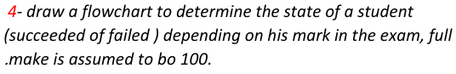

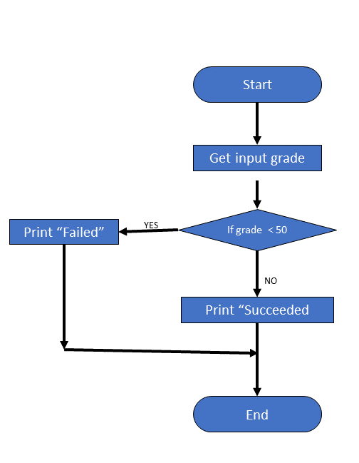

5- convert these numbers:

- 10 1110 1010
  - H 2EA
- FFEA
  - B 1111 1111 1110 1010
- 76
  - B 0100 1100
- 84
  - H 54

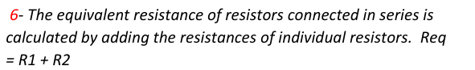
# include <iostream>
using namespace std;

int main(){
float R1, R2;
cout << "enter R1 value: ", cin >> R1;
cout << "enter R2 value: ", cin >> R2;
cout << "equivalent resistance when connection is: " << endl;
cout << "in series: " << R1+R2 << endl;
cout << "in parallel: " << (R1*R2)/(R1+R2);
return 0;
}

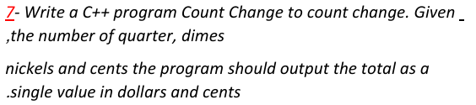
# include <iostream>
using namespace std;

int main(){
// define variables
float quarter, dime, nickel, cent, total;
// get inputs
cout << "enter quarters: " ,cin >> quarter;
cout << "enter dime: " ,cin >> dime;
cout << "enter nickel: " ,cin >> nickel;
cout << "enter cent: " ,cin >> cent;
// calculate total in dollars and cents
total = ((dime * 10) + (nickel * 5) + (quarter * 25) + cent)/100;
cout << "total in dollars and cents: " << total;
return 0;
}
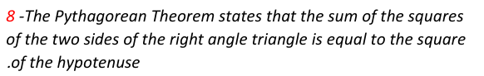
# include <iostream>
# include <cmath>
using namespace std;

int main(){
float m, n, a, b, c;
cout << "enter m value: " , cin >> m;
cout << "enter n value: " , cin >> n;
a = pow(m,2) - pow(n,2);
b = 2*m*n;
c = sqrt(pow(a,2)+pow(b,2));
cout << a<< endl << b << endl << c << endl;
return 0;
}
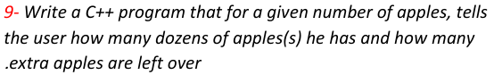
# include <iostream>
using namespace std;

int main(){
int apples, dozens;
cout << "enter apples number: " , cin >> apples;
dozens = apples / 12;
apples = apples % 12;
cout << dozens << " dozens and " << apples << " apples";
return 0;
}
END OF SHEET 1

SHEET 2
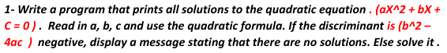
# include <iostream>
# include <cmath>
using namespace std;

int main(){
float a, b, c, x, x1, x2;
cout << "enter a value: " , cin >> a;
cout << "enter b value: " , cin >> b;
cout << "enter c value: " , cin >> c;
switch((b*b) > (4*a*c)){
case 1:
x1 = (-b + sqrt((b*b)+4*a*c))/2*a;
x2 = (-b + sqrt((b*b)-4*a*c))/2*a;
cout << "x1: " << x1 << endl;
cout << "x2: " << x2;break;
default:cout << "equation not solvable";break;
}
return 0;
}

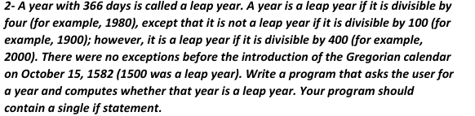
# include <iostream>
using namespace std;

int main(){
int x, y;
cout << "enter year: " , cin >> x;
if (((x>=1582 && (x%4 == 0 && x%100 != 0)) || (x%400 == 0)) || (x < 1582 && x&4 ==0)){
cout << "it's a leap year";
}
else{
cout << "it's not a leap year";
}
return 0;
}
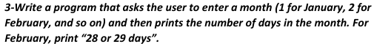
# include <iostream>
using namespace std;

int main() {
int input;
cin >> input;
switch (input) {
case 1:case 3:case 5:case 7:
case 8:case 10:case 12:cout << "31 days.";break;
case 4:case 6:case 11:cout << "30 days.";break;
case 2:cout << "28 or 29 days.";break;
}
return 0;
}

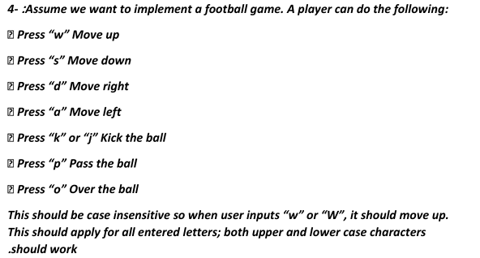
# include <iostream>
# include <cctype>
using namespace std;

int main(){
char move;
cout << "choose your move: ", cin >> move;
switch(tolower(move)){
case 'w':cout << "Move up" ;break;
case 's':cout << "Move down" ;break;
case 'd':cout << "Move right" ;break;
case 'a':cout << "Move left" ;break;
case 'k':cout << "Kick the ball" ;break;
case 'j':cout << "Kick the ball" ;break;
case 'p':cout << "pass the ball" ;break;
case 'o':cout << "Over the ball" ;break;
default :cout << "Invalid input";
}
return 0;
}

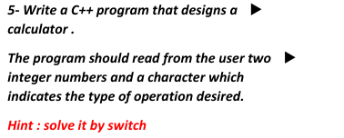
# include <iostream>
using namespace std;

int main(){
int x, y;
char sign;
cout << "enter number: ", cin >> x;
cout << "enter sign: ", cin >> sign;
cout << "enter number: ", cin >> y ;
switch(sign){
case '+':cout << "result: " << (x+y);break;
case '-':cout << "result: " << x-y;break;
case '*':cout << "result: " << x*y;break;
case '/':cout << "result: " << x/y;break;
default:cout << "Invalid input";
}
return 0;
}

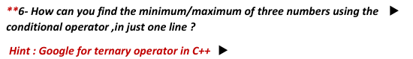
# include <iostream>
using namespace std;

int main(){
int min,max;
int n1,n2,n3;
cout << "enter n1 value: " ,cin >> n1;
cout << "enter n2 value: " ,cin >> n2;
cout << "enter n3 value: " ,cin >> n3;
max = (n1 > n2) ? ((n1 > n3) ? n1 : n3) : ((n2 > n3) ? n2 : n3);
min = (n1 < n2) ? ((n1 < n3) ? n1 : n3) : ((n2 < n3) ? n2 : n3);
cout << "max is: " << max << endl;
cout << "min is: " << min;
return 0;
}

